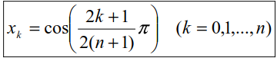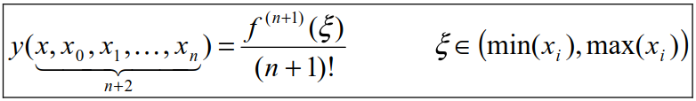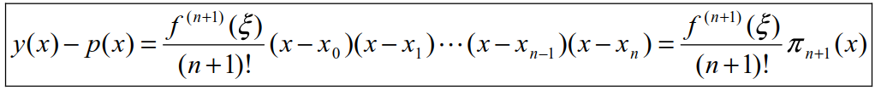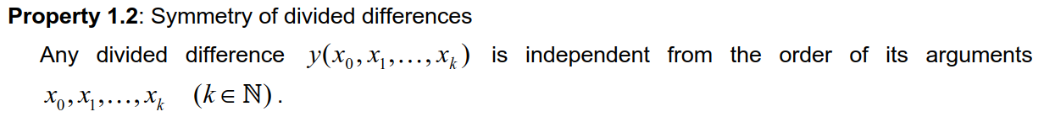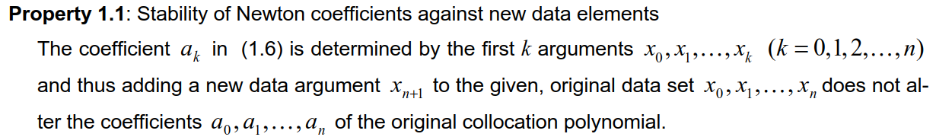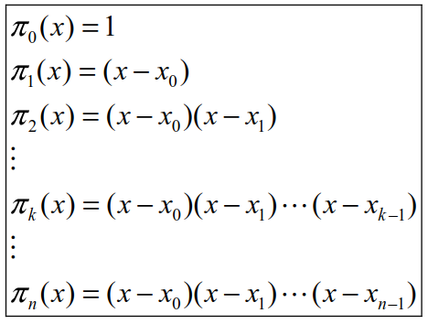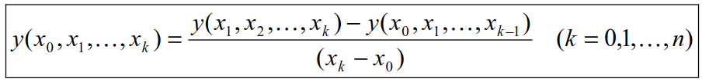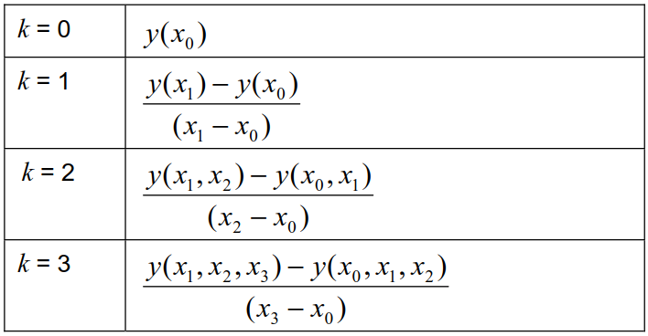

**Chebyshev arguments to counter the Runge phenomenon**

within boundaries min, max

n = large 🡪 derivative = large 🡪 risk for oscillation at boundaries 🡪 Runge phenomenon

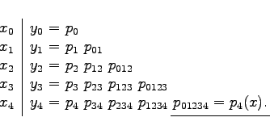

iterative!

recursive!

**Aitken Neville tabular scheme**

given: data points of a data set or a function that is to be interpolated as a polynomial  
(x0, y0) (x1, y1) … (xn, yn)

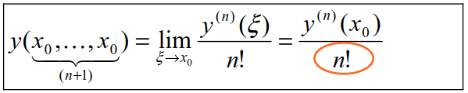



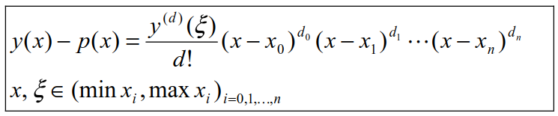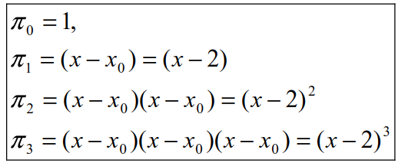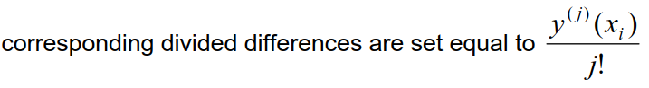

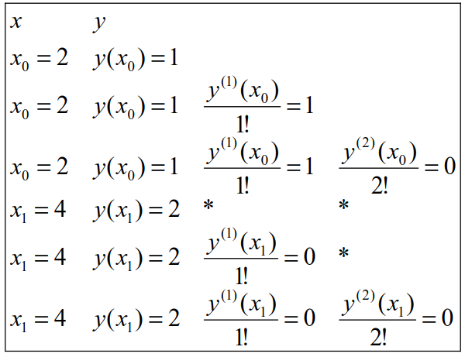

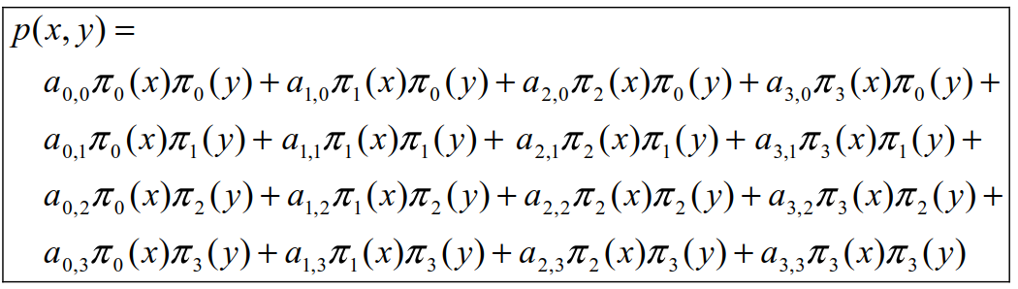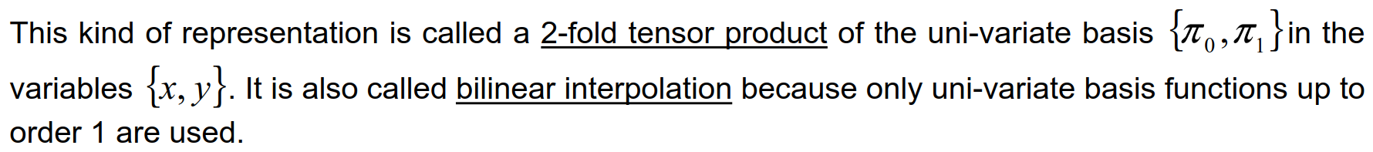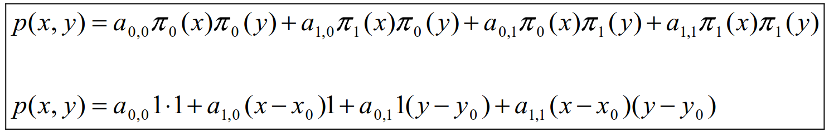

TODO



y: linear  
x: cubic

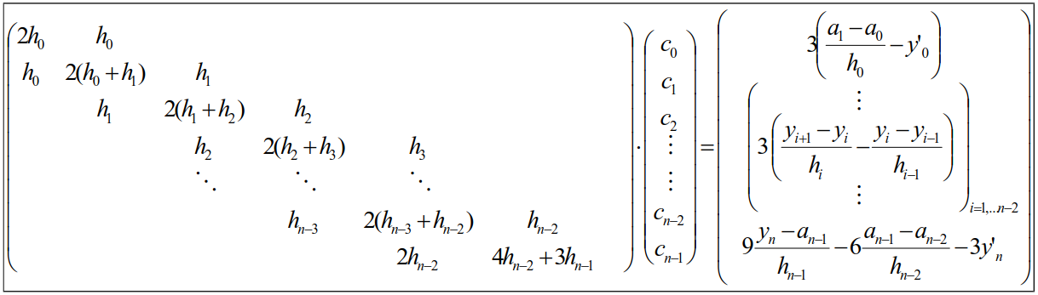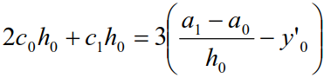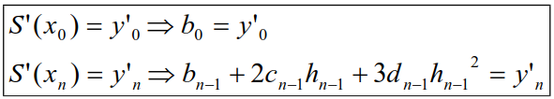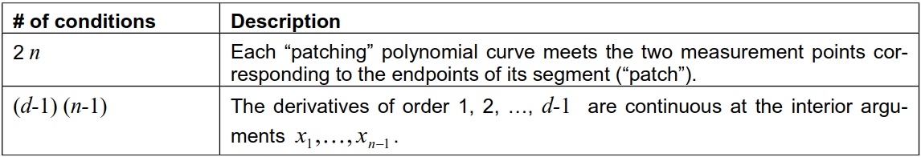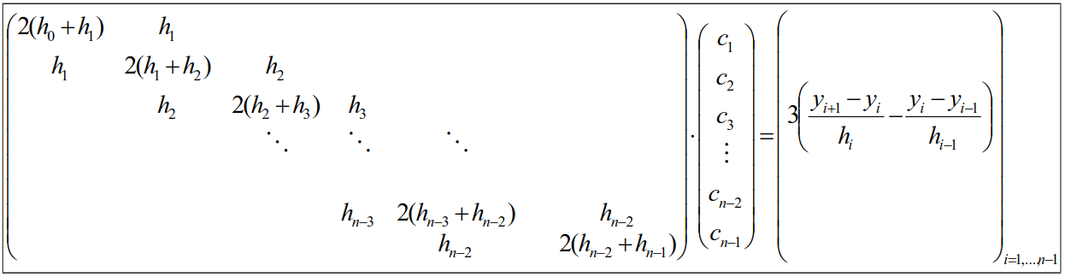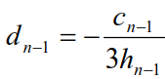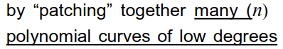



1. *ai = yi*  
2. calc *ci*  
3. calc *di* and *dn-1*  
4. calc *bi*

linear system

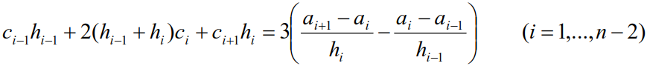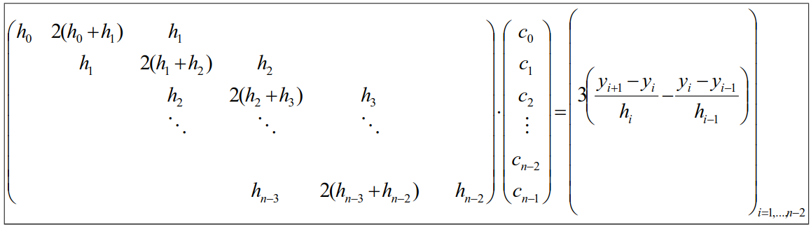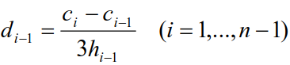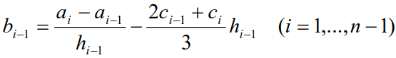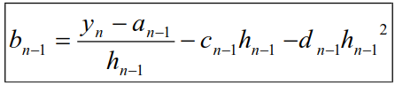

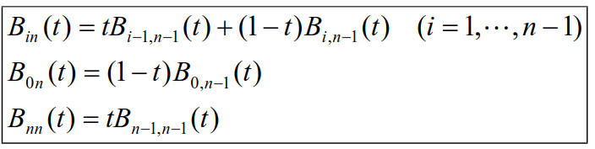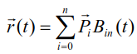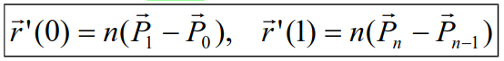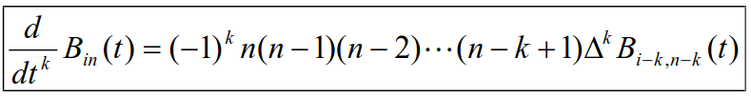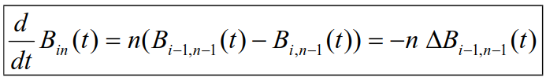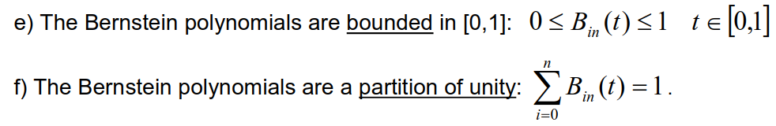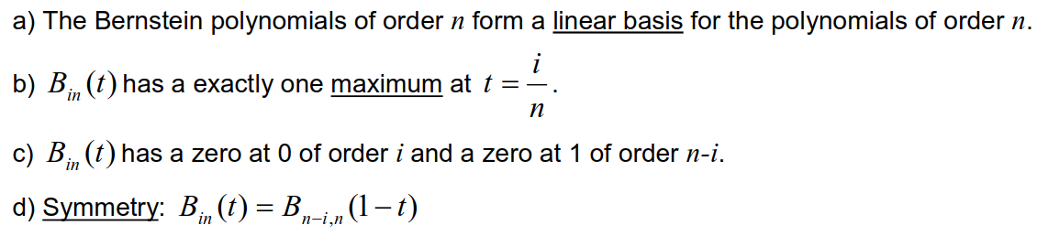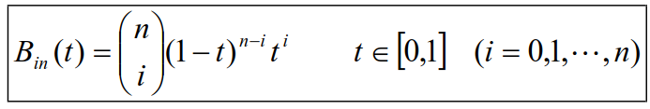

n = degree  
m = nr. of patches

Control Points

if rQ and rP are two connected Bezier patches



recursive calculation of higher orders



for discrete data containing noise, where an interpolation makes not much sense

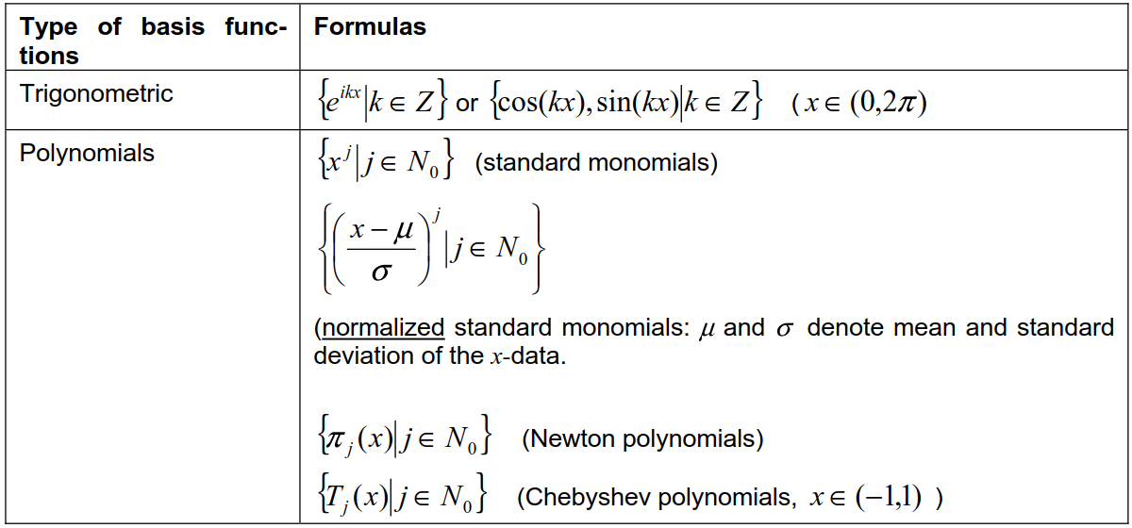

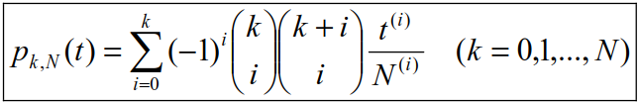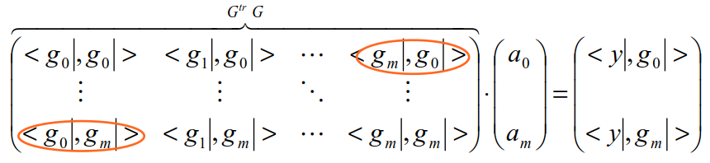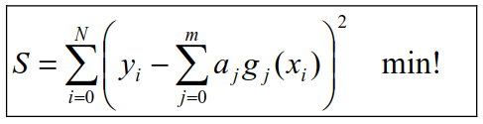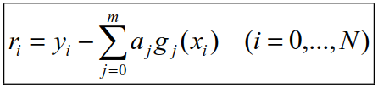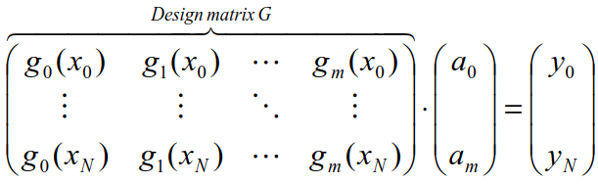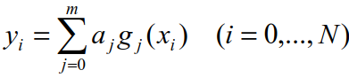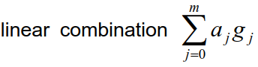

and have new basis functions  
{g0 = p0,N g1 = p1,N … gN = pN,N }

!!! iterate **k** and **i**  
then continue with the Design Matrix

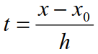

substitute

for uniformly spaced arguments

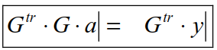

S is minimal only if

error / residuals ri



N : number of datapoints  
m : degree of basis functions g

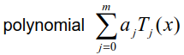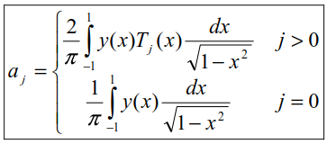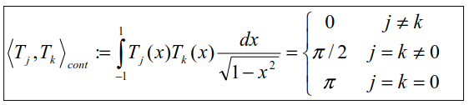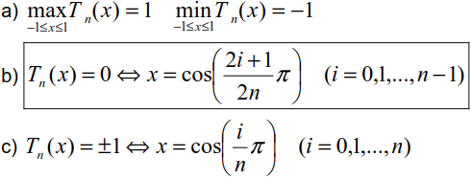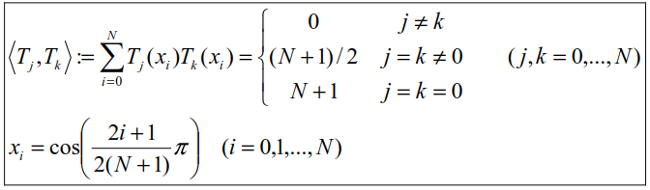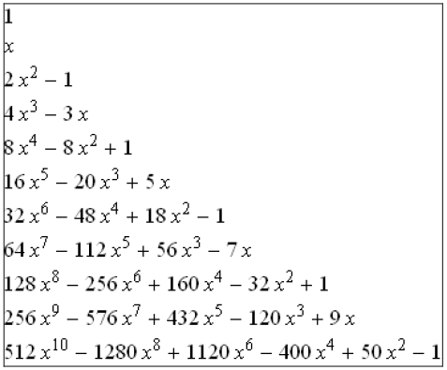

S = sum of square resudials

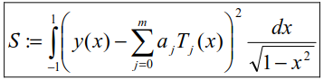

Polynom muss skaliert werden



N=n (N+1) = # of measurements

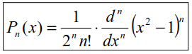

weighing function

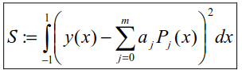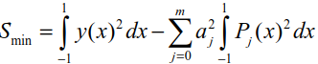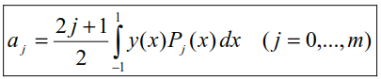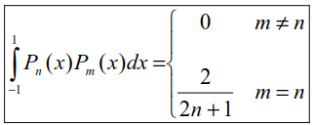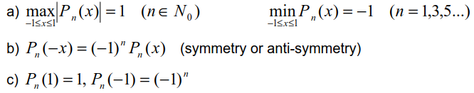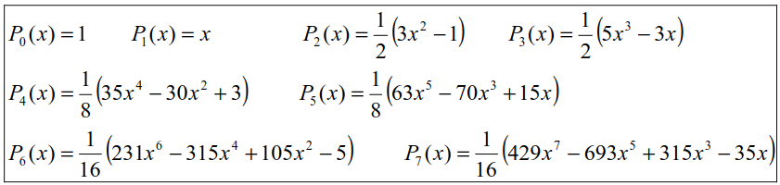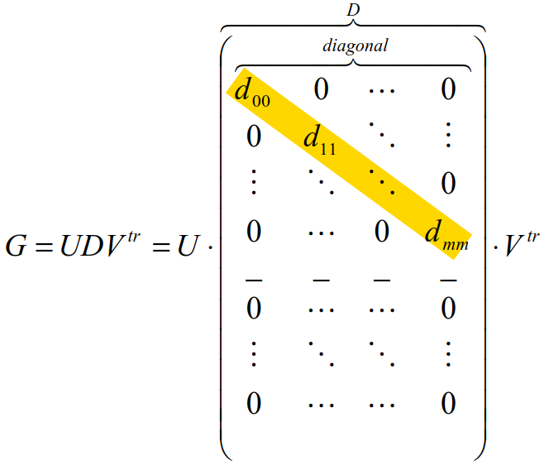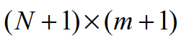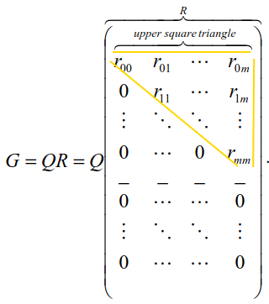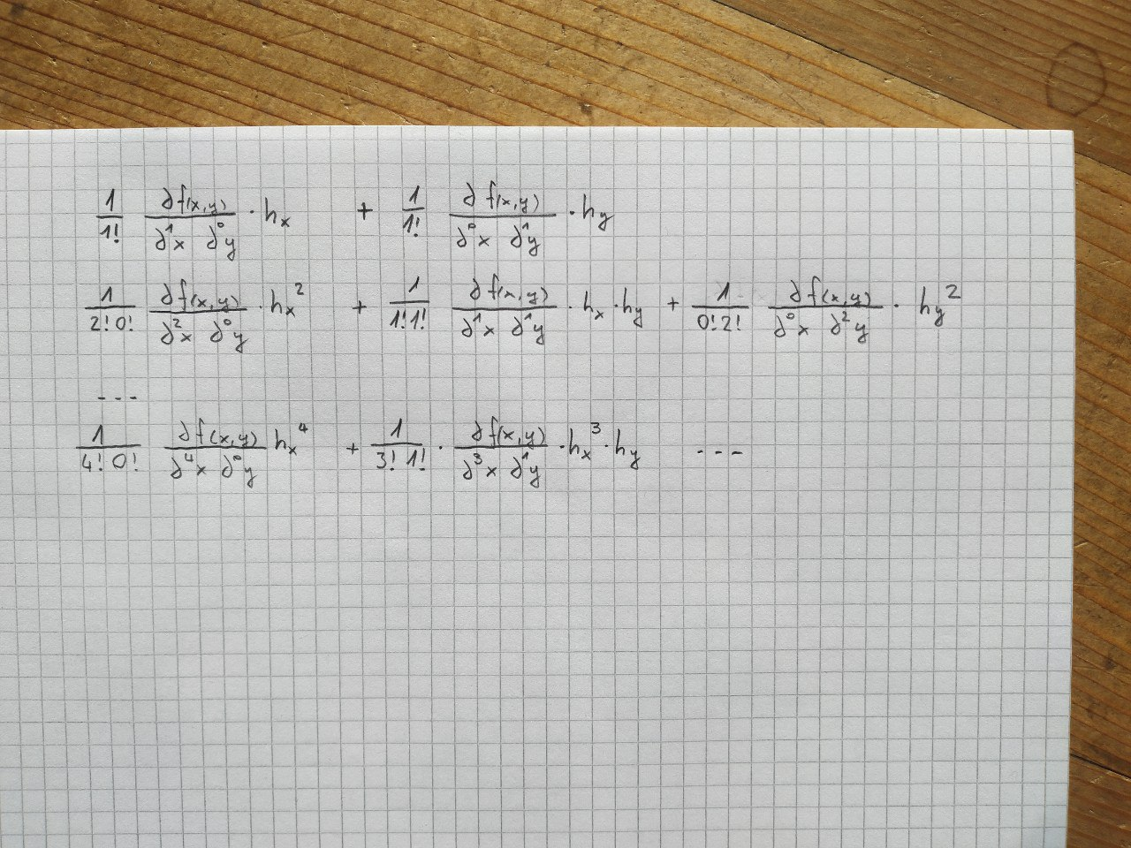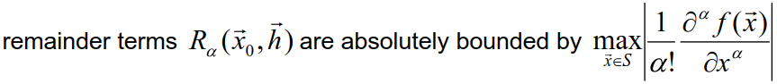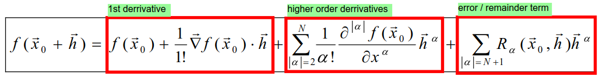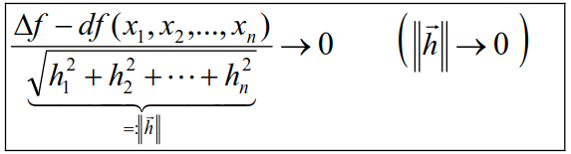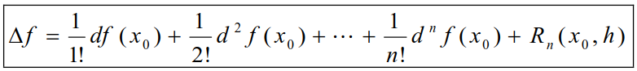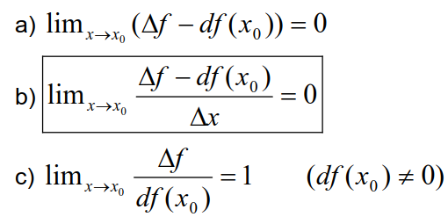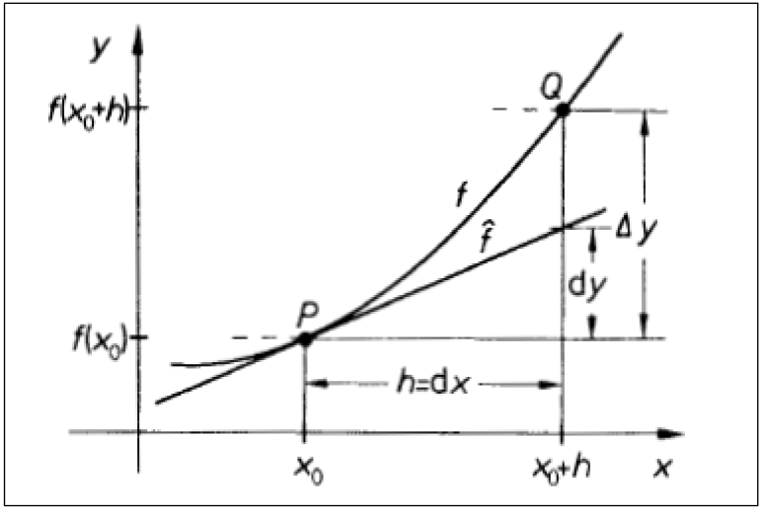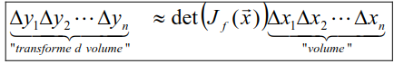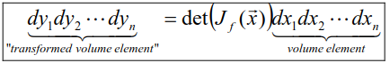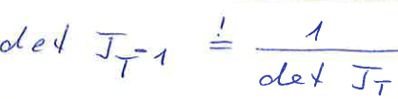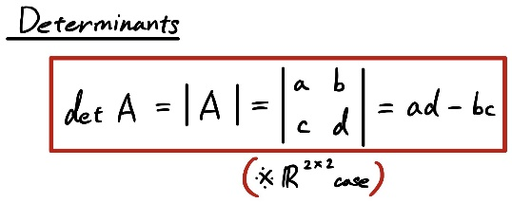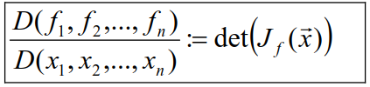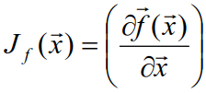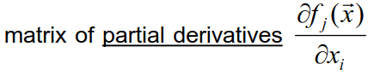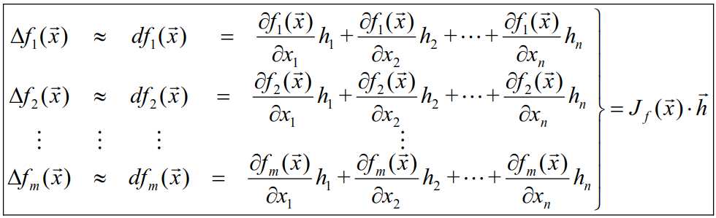



D = sqrt( GT x G )  
(square root of Eigenvalues)

N = # of points -1 {0…N}  
m = rank (x2 🡪 m=2)



more computational costs + more stable than QR-decomp.

I = identity matrix (1’s in diagonal)



e.g.  
α3 = {(3,0), (2,1), (1,2), (0,3)}  
sum |α| 🡪 always 3



error tends to 0 for h to 0

TODOOOOOOOOO



Matrix does not have + between partial derivatives

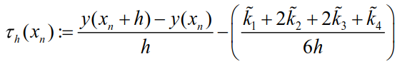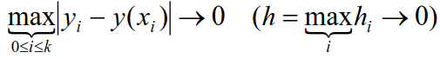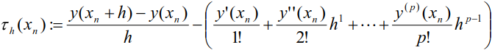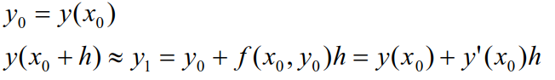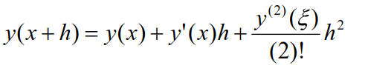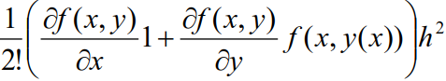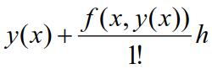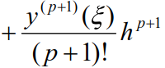



runge kutta

taylor

global error

local error

global error: max error of entire data set  
local error: error at individual points with ideal starting conditions (w/o error propagation)

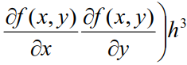

Taylor Series (approximation)

Lagrange Error

right hand side

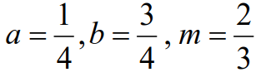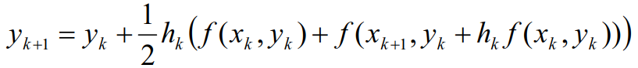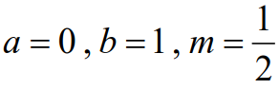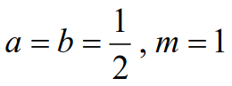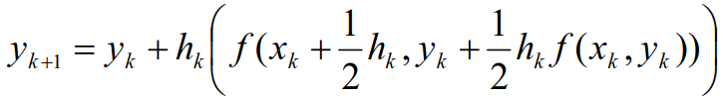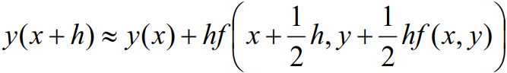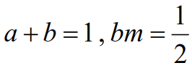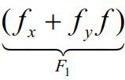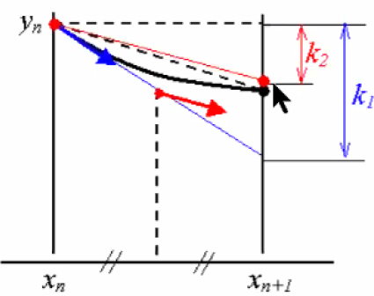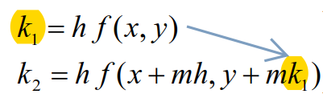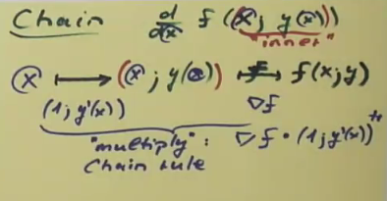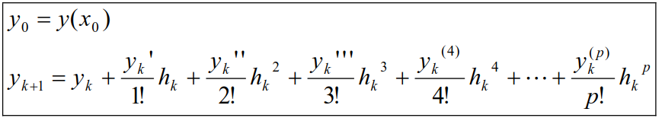

h = step size

$$y^{'}=f\left(x, y_{(x)}\right)$$

$$y''=\left[\frac{∂}{∂x}y'; \frac{∂}{∂y}y'\right]⋅\left[\begin{matrix}1 \\ y'\end{matrix}\right]$$

$$y'''=\left[\frac{∂}{∂x}y''; \frac{∂}{∂y}y''\right]⋅\left[\begin{matrix}1 \\ y'\end{matrix}\right]$$

$$y^{'}=f\left(x, y_{(x)}\right)$$

$$y''=1⋅\frac{∂}{∂x}y' + \frac{∂}{∂y}y'⋅ y'$$

$$y'''=1⋅\frac{∂}{∂x}y'' + \frac{∂}{∂y}y''⋅ y'$$

**chain rule**f(x,y(x)) is known with the initial values

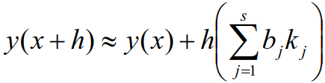

c = inputs (e.g. x)  
k = outputs (e.g. y)

k1 k2 … kS

